Portfolio – Smart Parcel Sorting System Hams Aljohani

System Overview

The Smart Parcel Sorting System is designed to streamline and automate the organization of parcels based on delivery routes and priority levels. It simulates a logistics hub where parcels are received, sorted, and prepared for dispatch using appropriate data structures for efficient processing.  
  
My responsibility in this project focused on implementing a stack for reversing batches of parcels. This functionality is essential when a group of parcels needs to be dispatched in the reverse order they were received, often due to last-minute changes in routing or delivery scheduling.

Additionally, I was responsible for designing and implementing the Tree-Based Hierarchy for Region-City-Zone Classification. This hierarchical structure ensures efficient organization of geographic data, allowing clear navigation from regions to cities and zones. The tree structure facilitates structured classification, making it easier to handle location-based queries and data retrieval efficiently.

Problem Description

In real-world parcel distribution systems, certain circumstances require reversing the delivery order of a batch of parcels. For instance, if the route of a delivery vehicle changes or urgent packages are added, the order of processing needs to be inverted. My task was to design and implement a solution to reverse a batch of parcels efficiently using a stack, which naturally supports LIFO (Last-In-First-Out) behavior.

Architecture

The system architecture includes multiple components working together to process parcels:  
- A queue structure is used for incoming parcels to maintain the original arrival sequence.  
- Arrays and linked lists are used for storing and organizing sorted parcels.  
- Stacks are used to reverse batches of parcels when needed.

The system architecture includes multiple components working together to process hierarchical classification:

* A tree structure is used to represent the region-city-zone hierarchy.
* - Binary tree nodes store hierarchical relationships between country, regions, cities, and zones.
* - Recursive traversal is employed for structured output and easy navigation of the hierarchy.

Data Structure Usage

the stack was implemented using a linked list to allow flexible, dynamic memory allocation. This approach makes the stack suitable for variable-sized parcel batches. Each node in the stack holds a parcel name and a pointer to the next parcel. This structure supports core stack operations including push, pop, peek, and isEmpty, along with a display function to visualize the current stack and a custom function to reverse an entire batch by popping all items.

- The tree-based hierarchy was implemented using binary tree nodes, allowing structured and logical classification. Each node holds:

- A name representing the region, city, or zone.

- Two child pointers (`left` and `right`) that define hierarchical relationships.

This structure supports core tree operations including:

- “Recursive insertion” of hierarchical nodes.

- “Hierarchical display function” using recursion.

- “Memory management” with dynamic allocation and deallocation of nodes.

My Contribution: Stack for Reversing Batches and Tree-Based Hierarchy for Region-City-Zone Classification

I implemented the 'ParcelStack' class using a linked list-based approach. The class includes:  
- `push()`: Adds a new parcel to the top of the stack.  
- `pop()`: Removes the top parcel from the stack.  
- `peek()`: Returns the parcel at the top without removing it.  
- `isEmpty()`: Checks whether the stack is empty.  
- `display()`: Prints all parcels in the stack from top to bottom.  
- `reverseBatch()`: Pops and displays all parcels to simulate batch reversal.

I implemented the ‘hierarchical classification system’ using a binary tree-based approach. My work focused on structuring data logically to represent regions, cities, and zones, ensuring a streamlined traversal method for visualization. The key components of my contribution are:

- `TreeNode` Structure:

- Defined a node structure representing a region, city, or zone.

- Included left and right pointers to establish parent-child relationships.

- Recursive Hierarchy Traversal (`displayHierarchy()`):

- Implemented a recursion-based traversal to output the hierarchy.

- Designed indentation logic to improve readability of the hierarchical structure.

- Building the Hierarchical Structure:

- Created a root node representing the country.

- Added regions, cities, and zones in a structured binary tree format.

- Memory Management:

- Used dynamic allocation (`new`) to create nodes.

- Implemented manual deallocation (`delete`) to free memory and prevent memory leaks.

Code snapshot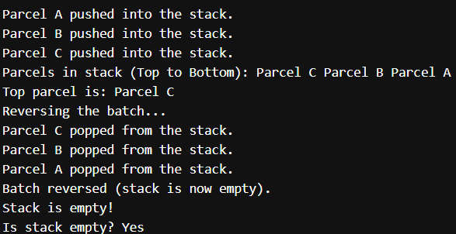

Bonus output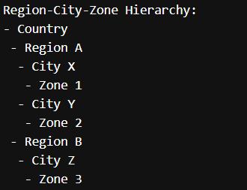

GitHub Repository

<https://github.com/Hams770/data-project-hams>